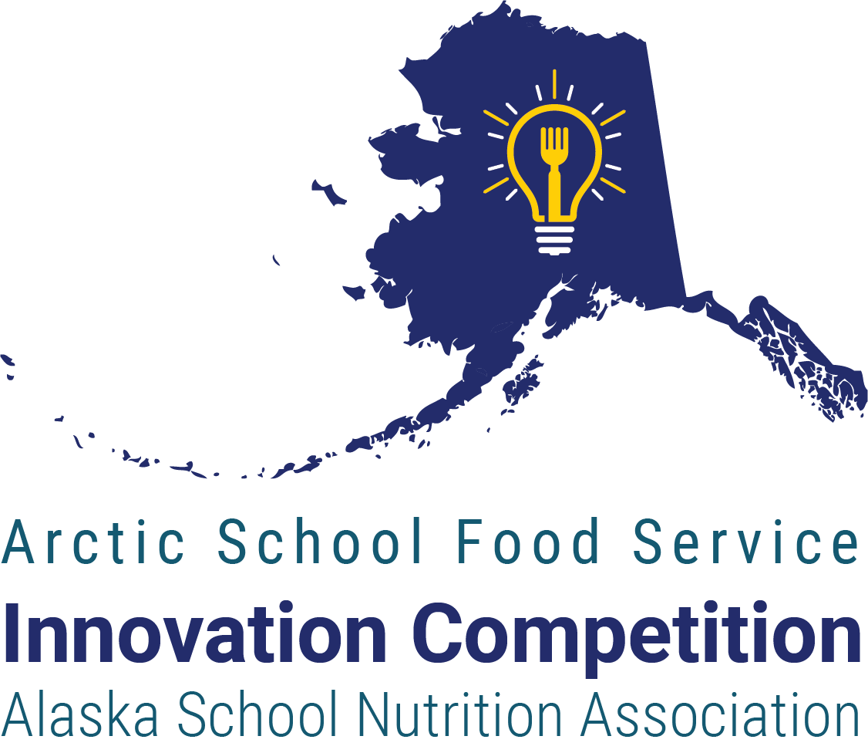

AKSNA is pleased to announce the third annual Arctic School Food Service Innovations Competition. The competition recognizes an individual in school food service that has contributed an innovation that has expanded access to school meals, improved the quality or nutritional value of school meals, improved student and community relationships of the school meal program, improved logistical or financial support of school meals, and/or overcome another challenge to making, distributing, and serving school meals.

The winner will be selected by people’s choice award at the 57th Annual AKSNA Conference in Anchorage, Alaska, 21 – 23 January 2025.  
The winner will receive travel and registration to the **SNA Annual National Conference in San Antonio, Texas**, 13 – 15 July 2025.

# Nominations

Anyone with direct knowledge of the innovation may nominate an Alaskan school nutrition professional; self-nominations are allowed. The person submitting the nomination need not be an AKSNA member. Examples of qualified nominators include the nominee, the nominee’s supervisor, colleague, business manager, teacher, principal, or superintendent.

To nominate an individual, complete the nomination form at <https://aksna.org/arctic-school-food-service-competition/>

Your nomination should include:

* The name and where the nominee is employed
* A photo of the nominee
* 2 – 4 PowerPoint (PPT/PPTX) slides presenting the nominee’s innovation.
  + The PowerPoint may contain a combination of text and images (no video).
  + Include a script to be read with each slide.
  + The total time to read the script should not take more than four minutes.
  + Do not include the nominee’s name, photo, or a title slide; one will be created separately.
* The PowerPoint should at minimum:
  + Describe the innovation and how the nominee was involved.
  + Describe how the innovation improved the nutrition program or addressed a challenge.
  + Describe the impact on students and the school community.
  + Include relevant facts and figures, such as increases in participation, reduction in cost, etc.

An AKSNA representative shall read the script provided. No additional testimony for the nominees will be permitted at the conference.

# Guidelines

## Eligibility and Judging

The nominee must be actively employed in a school nutrition profession. While attendance at the AKSNA Annual Conference is encouraged, the nominee need not be present to win.

Up to three nominees will be presented to the attendees of the AKSNA Annual Conference; all persons attending the conference shall be eligible to cast one (1) vote. The winner will be determined by popular vote. AKSNA members in good standing on the day of the vote shall receive a bonus count equal to ten percent of total number of votes cast, rounded to the next lowest whole number.

If there are more than three qualified nominees, the AKSNA Board will convene a committee to review the nominations. At minimum, the top rated AKSNA member in good standing shall be presented for consideration; two additional nominees will be selected based on merit without regard to AKSNA membership status.

Tie breaking: In the unlikely event of a tie, then these tie-breaking procedures will occur sequentially until the tie is resolved. 1) If there is a tie between an AKSNA member in good standing and a non-member, the member shall be declared the winner. 2) The nominee whose complete application was received first shall be declared the winner. 3) The nominee shall be selected based upon the flip of a fair coin.The winning nominee will be announced at the AKSNA After Dark event.

## Award Details

The winner will attend the 2025 SNA Annual Conference in San Antonio, Texas, 13 - 15 July 2025.  
This includes:

* Conference registration including up to one preconference session *
* Airfare from the winner’s home city in Alaska to San Antonio, Texas (round-trip, economy class, traveling the most direct and economic route for business purpose)
* Lodging at one of SNA’s partner hotels
* A $300 cash allowance for meals and ground transportation

* The award shall be up to the cost of attendance at the applicable member rate, if the winner is not an SNA member, they must become a member prior to registering or pay the difference in fee.

## Registration and Travel Procedures

The winner shall be responsible for booking their own travel, lodging, and registering to attend the conference. The winner shall submit to AKSNA, at one time, the following documents for payment:

* Receipt for airfare including the total cost, traveler’s name, itinerary, e-Ticket, and airline confirmation code (unredacted).
  + If the winner selects routing that is not the most direct, economical route or purchases an upgrade to premium or first class, the winner shall provide evidence of the most direct, economical route, the traveler will be reimbursed actual cost up to the cost of the most direct, economical route.
  + Failure to do so will result in AKSNA reimbursing travel best on the best available data, if such data cannot be obtained, AKSNA shall reimburse the winner $200 for the round-trip airfare.
* Receipt for conference registration, including pre-conference registration.
* Confirmation from the SNA Housing Bureau (or it’s hotel booking partner if other than the Housing Bureau) including the traveler’s name, hotel name, the dates of lodging, and confirmation number.
  + The hotel need not be prepaid, AKSNA will reimburse the full cost of the hotel upfront without a folio.
  + If the winner books a hotel outside of the SNA hotel block, the traveler will be reimbursed the actual cost of lodging up to the median cost of hotels available from the SNA hotel block.

## Federal Income Tax

If the winner elects to receive the reimbursement personally, an additional cash allowance equal to 28.2% of the total cash value of the prize shall be paid to the winner; the amount is intended, but not guaranteed, to offset the winner’s Federal Income Tax liability.

# *About the Alaska School Nutrition Association*

AKSNA is the state affiliate of the School Nutrition Association (SNA), a national, nonprofit professional organization representing more than 46,000 members who provide high-quality, low-cost meals to students across the country. Recognized as the authority on school nutrition, SNA has been advancing the availability, quality and acceptance of school nutrition programs as an integral part of education since 1946.